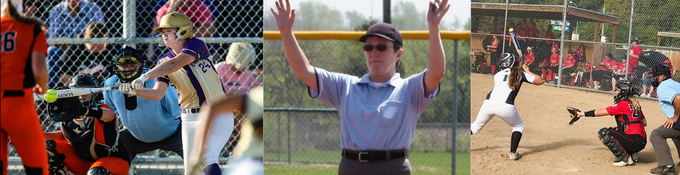

KSOA Softball

February 2022

Upcoming Dates…

**KSHSAA test exam**:

Due: March 15

**KSHSAA Area Mtgs**: 7pm

3/21 @ Topeka-Hayden

3/23 @ Olathe West

Facilitator: Tom Drake

**KSHSAA season dates**:

* **March 17** - KSHSAA Games Begin
* **May 16 - 21** – KSHSAA Regional games
* **May 26 - 27** - KSHSAA State Tournament games

Committee Members

Joe Cunningham

Spensyr Downing

Tom Drake

Amy Merritt

Justin Smith

Linda Weber

**KSOA Softball clinic – Sat, Mar 19 (9 - 2pm)**

Classroom and game situations covered

* Classroom discussion of rules and mechanics will be reviewed
* Umpires will be provided on-the-field training experience and written evaluation that day
* Providing an opportunity for any umpire to be evaluated for ‘Call the Game’ / High school scheduling

Contact: Tom Drake [frontierleague_commish@hotmail.com](mailto:frontierleague_commish@hotmail.com)

Location: Gardner High School

**CTG / KSOA Softball meeting – Mar 8, 7pm**

Location: De Soto High School

* Rules exam will be reviewed so bring your completed test

**Summer softball umpire opportunities:**

**USA Softball** - Whether you are interested in umpiring leagues or tournaments, we have a position for you! Kansas City Metro Umpire-in-Chief, Darren Elliott can assist you in getting started.

**Contact info: softballcoach_13@yahoo.com**

**Blue Valley Recreation Complex** provides softball training for all umpire skill levels.

**Contact: Linda Weber** [**lweber@bluevallyrec.org**](mailto:lweber@bluevallyrec.org)

Interested in being a part of the KSOA Softball committee? Contact Amy Merritt

Questions…contact the KSOA Softball Coordinator: Amy Merritt [amerrit3@gmail.com](mailto:amerrit3@gmail.com)