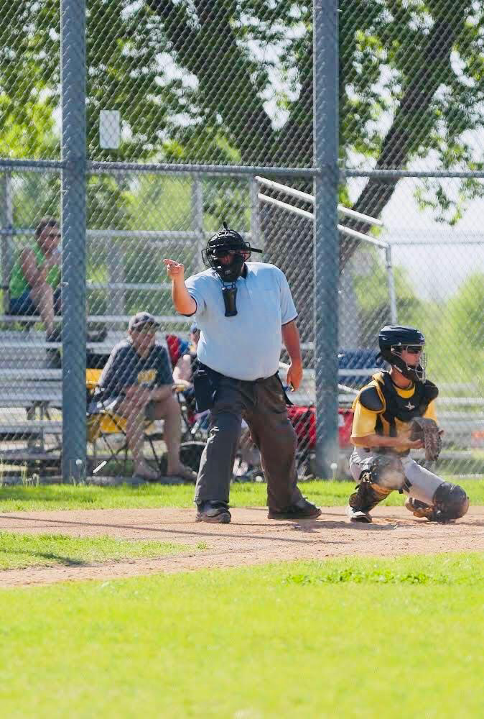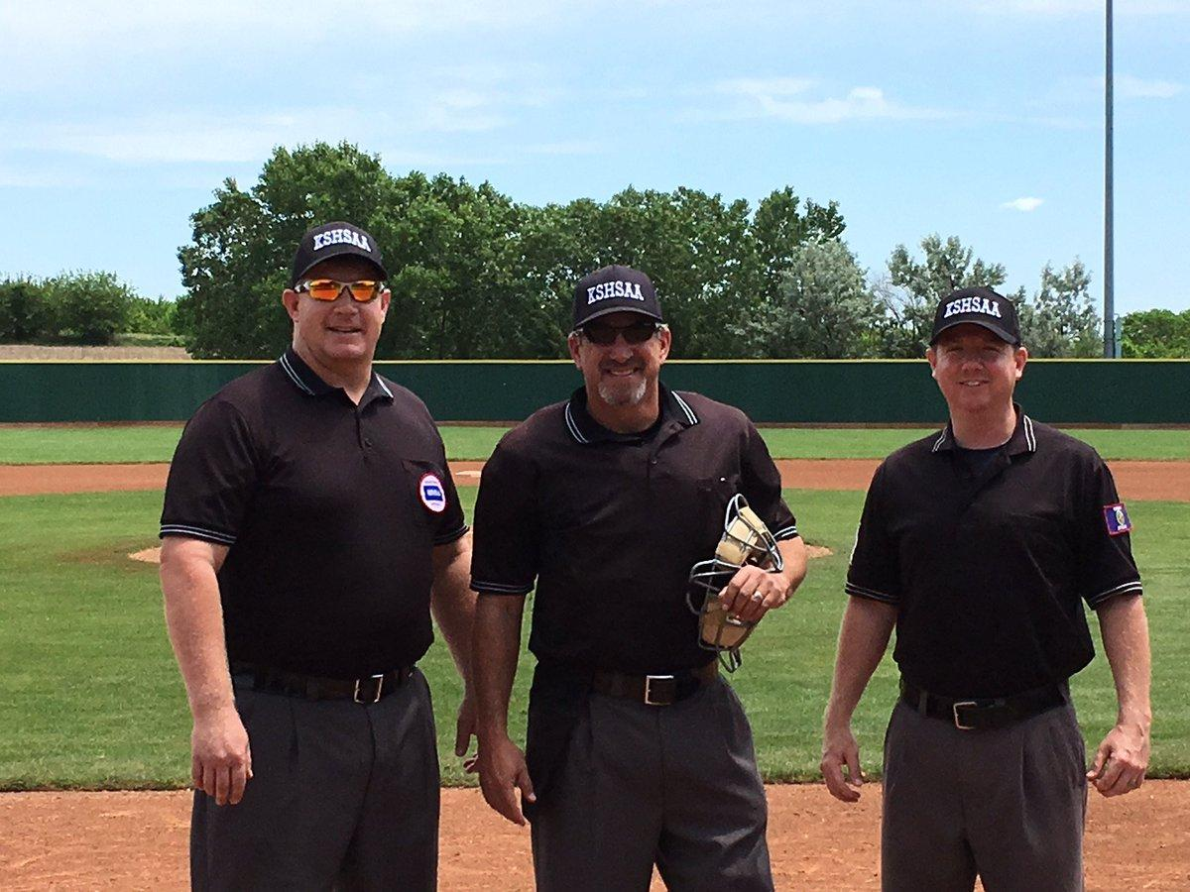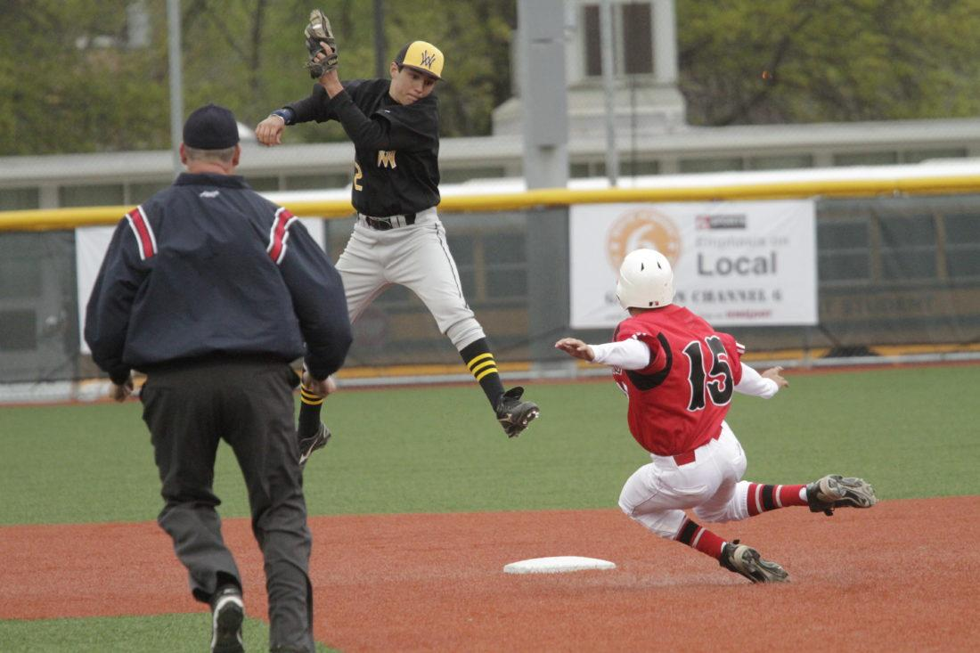

KSOA Baseball

Latest News

NCAA test for college umps was due two weeks ago, hope you remembered to get your answers submitted. If you are working NAIA, the deadline is still a ways out there but don’t delay, do the online clinic and get your test answers submitted.

KSHSAA Baseball in-person rules meetings have concluded; no major changes this year but we will still be educating coaches on the Player/DH rule that went into effect last year. Remember, no courtesy runner for the Pitcher/DH or Catcher/DH!

Mark your calendar for Area Supervisor Meetings, they are a great place to discuss rules and situations with your fellow blues!

Be sure to attend the annual Call The Game Spring Sports meeting on March 7th at Desoto High School. We will review the baseball test at the end of the meeting; please have your test already completed to participate.

**Rules Question of the Month:**

With the bases loaded and one out, B5 hits a line drive to the right-field fence. R3 and R2 both score, but R1 is thrown out at home. B5 safely reaches third, but missed first base. The defense properly appeals B5’s missing first base. Which of the following answer(s) is/are correct?

1. Two runs score.
2. One run will count.
3. No runs will be scored.

(C) All rule sets agree; no runs score when the third out is due to the BR not reaching 1st base successfully.

Upcoming 2022 Dates

3/7-Call The Game Preseason Mtg

3/15-KSHSAA Baseball Test Due

3/21-KSHSAA Area Baseball Mtg at Topeka/Hayden

3/23-KSHSAA Area Baseball Mtg at Olathe West

3/28 – KSOA Area Make-Up Meeting at JoCo Library/Lenexa City Centre branch

Committee Members

Chad McFarland

Scott Burch

Kurt Jones

Tom Delany

Roger Beason

Jim Clark

Lee Whitman

February, 2022