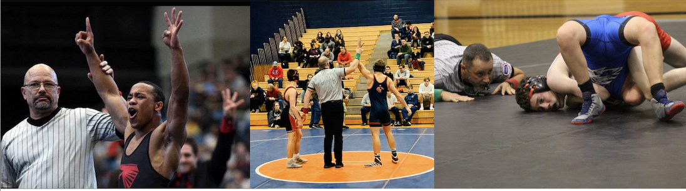

February 2022

KSOA Wrestling

Latest News

We want to congratulate the following wrestling officials for their state tournament selection:

* Jason Bloodgood (Girls 4-1A)
* Craig Ewert (Boys 5-6A)
* Angelo Giacalone (Boys 5-6A)
* Jim Ohlmeier (Boys 5-6A)
* Peter Sierant (Boys 5-6A)
* Dan Smith (Boys 5-6A)
* Rachael Woody (Girls 5-6A)
* Brad Clark (Lead Official Girls & Boys 5-6A)

We want to make note of two items out of this group...

* Craig Ewert received his 30 year recognition. Congratulations Craig!
* This is Peter Sierant's first state meet selection. Congratulations Peter!

Congratulations to all of these wrestling officials as well as to the rest of the KSOA Wrestling staff for an outstanding season!

Contact the KSOA Wrestling Committee at info@ksoasports.org.